House for Sale: 24 Nelson Street, Buff Bay, Portland Jamaica, West Indies
Freehold Interest
Price: All offers above £55,000.00 will be considered.
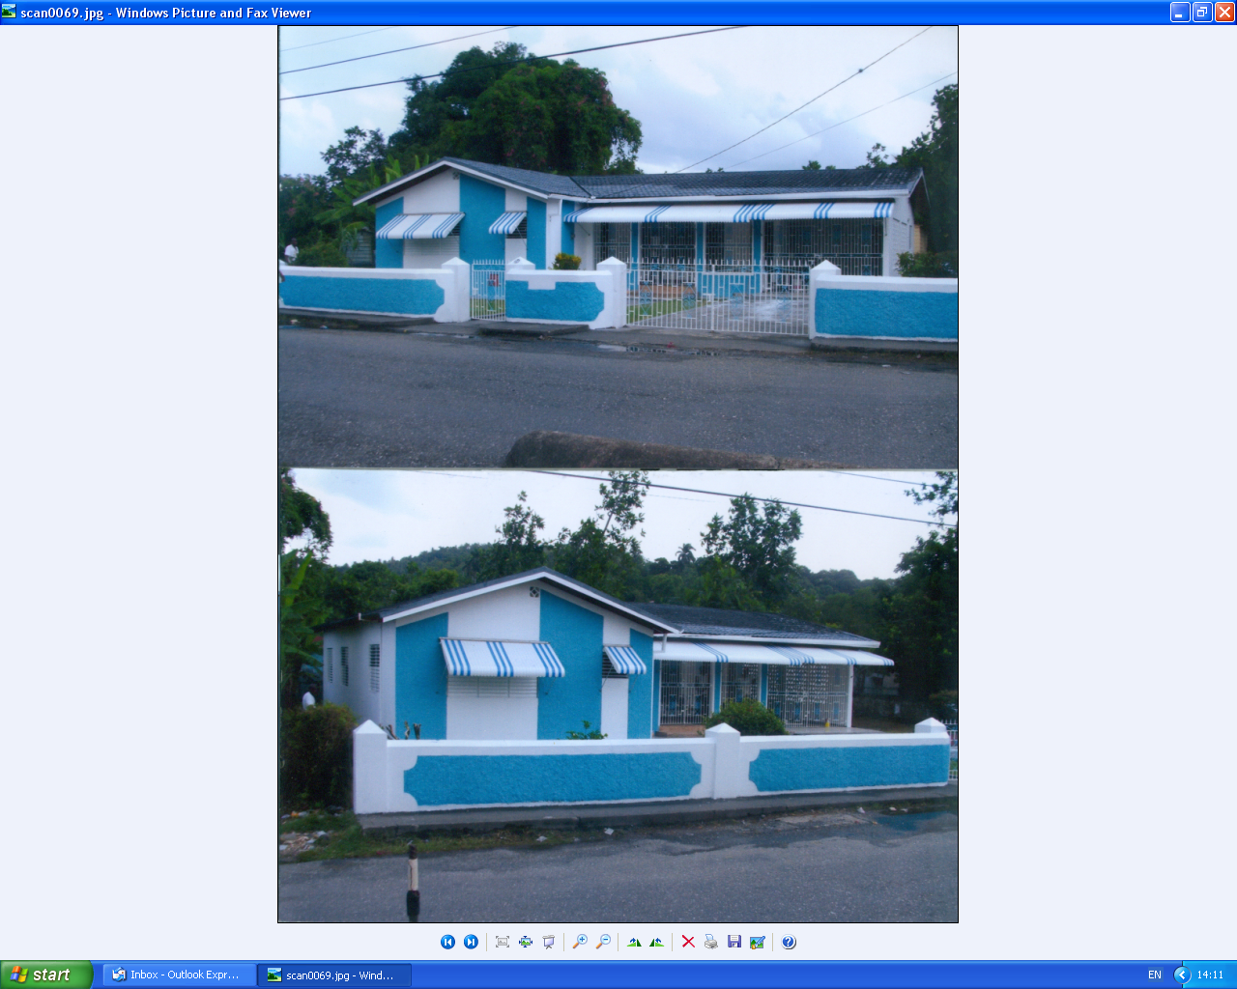
The lot contains an area of 705.37 Sq. Metres
Accommodation: There is a single storey dwelling house constructed on the site with the accommodation as follows:
Three (3) double bedrooms (one un-suite) / (two with built in closets), Two (2) bathrooms, Living room,
Dining room, Kitchen, Foyer, Utility room, Carport, Verandah, Laundry room
Area of building: Gross floor area is approximately 1,779.75sq.ft (165.34 sq.m)
The house has 220 and 110 voltage supplies, therefore all UK and US domestic electrical appliances work without adaptors.
The services are currently disconnected.

For sale details contact: Pascals College: 0208 663 6733, email: admin@pascalscollege.co.uk
Ms Jodi Lyn (Realtor)
j.lyn@century21jm.com

